Министерство науки и высшего образования Российской Федерации
Муромский институт (филиал)
Федерального государственного бюджетного образовательного учреждения высшего образования
«Владимирский государственный университет
имени Александра Григорьевича и Николая Григорьевича Столетовых»

Факультет ИТР
Кафедра ПИн

ЛАБОРАТОРНАЯ
РАБОТА №1

По Компьютерной графике

Руководитель
Привезенцев Д.Г.
(фамилия, инициалы)

(подпись) (дата)

Студент ПИн - 121
(группа)
Ермилов М.В.
(фамилия, инициалы)

(подпись) (дата)

Муром 2023
Лабораторная работа №1

Тема: Знакомство с Unity3D. Создание простейшей игры на Unity3D
Ход работы:
- Разработать простую 3д игру на Unity3D

.

Код проекта на юнити:
using System.Collections;
using System.Collections.Generic;
using UnityEngine;

public class Setting
{
static public class Control
{
static public class Key
{
static public string Jump = "space";
static public string Left = "a";
static public string Right = "d";
static public string Forward = "w";
static public string Backward = "s";
static public string Pause = /*"e";/*/"escape";
}
static public class Mouse
{
static public float SpeedX = 3;
static public float SpeedY = 1;
static public bool InversionX = false;
static public bool InversionY = false;
}
}
static public class Audio
{

static private float _VolumeSound = 1;
static public float VolumeSound
{
get => _VolumeSound;
set
{
if(value >= 0 && value <= 1)
_VolumeSound = value;
else if(value > 1)
_VolumeSound = 1;
else if (value < 0)
_VolumeSound = 0;
}
}
static private float _VolumeSoundCoinPickUp = 1;
static public float VolumeSoundCoinPickUp
{
get => _VolumeSoundCoinPickUp;
set
{
if (value >= 0 && value <= 1)
_VolumeSoundCoinPickUp = value;
else if (value > 1)
_VolumeSoundCoinPickUp = 1;
else if (value < 0)
_VolumeSoundCoinPickUp = 0;
}
}
static private float _VolumeSoundGemPickUp = 1;
static public float VolumeSoundGemPickUp
{
get => _VolumeSoundGemPickUp;
set
{
if (value >= 0 && value <= 1)
_VolumeSoundGemPickUp = value;
else if (value > 1)
_VolumeSoundGemPickUp = 1;
else if (value < 0)
_VolumeSoundGemPickUp = 0;
}
}
static private float _VolumeMusic = 0f;
static public float VolumeMusic
{
get => _VolumeMusic;
set
{
if (value >= 0 && value <= 1)
_VolumeMusic = value;
else if (value > 1)
_VolumeMusic = 1;
else if (value < 0)
_VolumeMusic = 0;
}
}
}
}
using System;
using System.Collections.Generic;
using System.Linq;
using System.Text;
using System.Threading.Tasks;
using System.Timers;
using UnityEditor;
using UnityEngine;

//[InitializeOnLoad]
public class GameInfo
{
static public bool isBattled => TriggeredEnemy > 0;
static public int TriggeredEnemy = 0;
static public bool isPaused = true;
static public int Coin = 0;
static public int Gem = 0;
static public float SpeedForward = 15f;
static public float Speed = 10f;
static public float SpeedJump = 25f;
//static private int DayCycle = 200;
//static private int time = 0;
//static public int Time => time;
// static public int DayTime => DayCycle * 2;
//static public bool isDay => time >= 0 ? true : false;
//static System.Timers.Timer Letimer;

/*static GameInfo()
{
//Time.
//Time.fixedDeltaTime = 0.05f;
//Letimer = new System.Timers.Timer(100);
//Letimer.Elapsed += timer;
//Letimer.Start();
}*/

/*static void timer(object sender, ElapsedEventArgs e)
{
time += 1;
if (time == DayCycle)
time = -DayCycle;
}*/
}
using System;
using System.Collections.Generic;
using System.Linq;
using System.Text;
using System.Threading.Tasks;
using UnityEngine;

public class MonoBehaviourPaused : MonoBehaviour
{
bool isPaused = GameInfo.isPaused;
private void Update()
{
if (!GameInfo.isPaused)
_Update();
_UpdateNonPaused();
}
private void FixedUpdate()
{
if(isPaused != GameInfo.isPaused)
{
isPaused = GameInfo.isPaused;
if(isPaused)
_Pause();
else
_Play();
}
if (!GameInfo.isPaused)
_FixedUpdate();
_FixedUpdateNonPaused();
}
protected virtual void _Update() { }
protected virtual void _FixedUpdate() { }
protected virtual void _UpdateNonPaused() { }
protected virtual void _FixedUpdateNonPaused() { }
protected virtual void _Play() { }
protected virtual void _Pause() { }
}
using System;
using System.Collections.Generic;
using System.Linq;
using System.Text;
using System.Threading.Tasks;
using UnityEngine;

public class RigidbodyGame : MonoBehaviourPaused
{
[SerializeField]
float DeadY = -5f;
[SerializeField]
bool Respawn = false;
[SerializeField]
Vector3 RespawnPosition = Vector3.zero;
[SerializeField]
bool Rotation = false;

Rigidbody R;
Transform T;
private Vector3 _pausedVelocity;
private Vector3 _pausedAngularVelocity;
private void Start()
{
T = GetComponent<Transform>();
R = GetComponent<Rigidbody>();
R.freezeRotation = !Rotation;
}
protected override void _FixedUpdate()
{
if (T.position.y < DeadY)
{
if (Respawn)
T.position = new Vector3(RespawnPosition.x, RespawnPosition.y, RespawnPosition.z);
else
{
Debug.Log(T.position);
Debug.Log(R.velocity);
Destroy(gameObject);
}
}
}
protected override void _Pause()
{
_pausedVelocity = R.velocity;
_pausedAngularVelocity = R.angularVelocity;
R.isKinematic = true;
}
protected override void _Play()
{
R.isKinematic = false;
R.velocity = _pausedVelocity;
R.angularVelocity = _pausedAngularVelocity;
}
}
using System.Collections;
using System.Collections.Generic;
using UnityEngine;

public class PlayerControl : MonoBehaviourPaused
{
Rigidbody R;
Transform T;

float Speed = 12.5f;
int isGround = 0;
bool isJump = false;

private void Start()
{
R = GetComponent<Rigidbody>();
T = GetComponent<Transform>();
}
protected override void _FixedUpdate()
{
Move();
RotateCamera();
}
private void OnTriggerEnter(Collider other)
{
if (other.tag == "Ground")
isGround++;
}
private void OnTriggerExit(Collider other)
{
if (other.tag == "Ground")
{
isGround--;
if (isGround < 0)
isGround = 0;
}
}
private void Move()
{
float MoveZ = 0;
float MoveX = 0;
float MoveJump = 0;
if(R.velocity.y <= 0 && isGround > 0)
isJump = false;
if(isGround > 0 && !isJump)
{
if (Input.GetKey(Setting.Control.Key.Right))
MoveX += GameInfo.Speed;
if (Input.GetKey(Setting.Control.Key.Left))
MoveX -= GameInfo.Speed;
if (Input.GetKey(Setting.Control.Key.Backward))
MoveZ -= GameInfo.Speed;
if (Input.GetKey(Setting.Control.Key.Forward))
if (MoveZ != 0)
MoveZ = 0;
else if(MoveX != 0)
MoveZ += GameInfo.Speed;
else
MoveZ += GameInfo.SpeedForward;
if (Input.GetKey(Setting.Control.Key.Jump))
{
MoveJump = GameInfo.SpeedJump * GameInfo.Speed;
if(MoveX > 0)
MoveX += GameInfo.SpeedJump;
if (MoveX < 0)
MoveX -= GameInfo.SpeedJump;
if (MoveZ > 0)
MoveZ += GameInfo.SpeedJump;
if (MoveZ < 0)
MoveZ -= GameInfo.SpeedJump;
isJump = true;
}
}
R.AddForce(Quaternion.Euler(0, GetComponent<Transform>().eulerAngles.y, 0) * new Vector3(MoveX, MoveJump, MoveZ));
}
private void RotateCamera()
{
if(!Cursor.visible)
{
T.RotateAround(T.position, T.up,
Input.GetAxis("Mouse X") * Setting.Control.Mouse.SpeedX * (Setting.Control.Mouse.InversionX ? -1 : 1));
/*T.RotateAround(T.position, T.right,
Input.GetAxis("Mouse Y") * Setting.Control.Mouse.SpeedY * (Setting.Control.Mouse.InversionY ? -1 : 1)));*/
}
}
}
using System.Collections;
using System.Collections.Generic;
using UnityEngine;

public class Rotation : MonoBehaviourPaused
{
[SerializeField]
float RotateInSeconds = 5.0f;
Vector3 rotor = new Vector3(0, 0, 0);
private void Start()
{
rotor = new Vector3(0, (360 / RotateInSeconds) / (1 / Time.fixedDeltaTime), 0);
}
protected override void _FixedUpdate()
{
transform.eulerAngles += rotor;
}
}

using System.Collections;
using System.Collections.Generic;
using UnityEngine;

public class Drop : MonoBehaviour
{
[SerializeField]
DropType DropType = DropType.Coin;
[SerializeField]
int Count = 1;

AudioSource source;
private void Start()
{
source= GetComponent<AudioSource>();
}
private void OnTriggerEnter(Collider other)
{
if (other.tag == "Player")
{
float volume = Setting.Audio.VolumeSound;
switch(DropType)
{
case DropType.Coin:
volume *= Setting.Audio.VolumeSoundCoinPickUp;
GameInfo.Coin += Count;
break;
case DropType.Gem:
volume *= Setting.Audio.VolumeSoundGemPickUp;
GameInfo.Gem += Count;
break;
}
Count = 0;
AudioSource.PlayClipAtPoint(source.clip, GetComponent<Transform>().position, volume);
Destroy(gameObject);
}
}
}
using System;
using System.Collections.Generic;
using System.Linq;
using System.Text;
using System.Threading.Tasks;
using TMPro;
//using UnityEditor.PackageManager.UI;
using UnityEngine;
using UnityEngine.UI;

class PlayerUI : MonoBehaviourPaused
{
[SerializeField]
TextMeshProUGUI TextGem;
[SerializeField]
TextMeshProUGUI TextCoin;
[SerializeField]
GameObject MenuPaused;
[SerializeField]
GameObject MenuPausedSetting;

private void Start()
{
UpdateText();
}

protected override void _FixedUpdateNonPaused()
{
UpdateText();
if(Input.GetKeyDown(Setting.Control.Key.Pause))
{
Pause();
}
if (Input.GetMouseButtonDown(0) && GameInfo.isPaused)
Play();
}

void Play()
{
Cursor.lockState = CursorLockMode.Locked;
GameInfo.isPaused = false;
Cursor.visible = false;
}
void Pause()
{
Cursor.lockState = CursorLockMode.None;
GameInfo.isPaused = true;
Cursor.visible = true;
}
void UpdateText()
{
TextGem.text = $"Gem {GameInfo.Gem}";
TextCoin.text = $"Coin {GameInfo.Coin}";
}
}
using System.Collections;
using System.Collections.Generic;
using UnityEngine;

public class Music : MonoBehaviour
{

AudioSource A;
[SerializeField]
AudioClip Background;
[SerializeField]
AudioClip Battle;

void Start()
{
A = GetComponent<AudioSource>();
A.clip = Background;
A.loop = true;
FixedUpdate();
}
void FixedUpdate()
{

//if (GameInfo.isBattled)
//newAudio(Battle, true);
//else if (!GameInfo.isBattled)
//newAudio(Background, false);

if (GameInfo.isPaused && A.isPlaying)
{
A.Pause();
}
else if (!GameInfo.isPaused && !A.isPlaying)
{
A.volume = Setting.Audio.VolumeMusic;
A.Play();
}

}
}
using System;
using System.Collections.Generic;
using System.Linq;
using System.Text;
using System.Threading.Tasks;
using System.Xml;
using UnityEngine;
using UnityEngine.AI;

public class AI_1 : MonoBehaviourPaused
{
[SerializeField]
AI_Trigger AreaVisibility;
[SerializeField]
AI_Trigger AreaPursuit;
[SerializeField]
float Speed = 1f;
bool Action = false;
NavMeshAgent N;
Transform T;
private void Start()
{
N = GetComponent<NavMeshAgent>();
T = GetComponent<Transform>();
N.speed = Speed;
}
protected override void _FixedUpdate()
{
if(AreaVisibility.isPlayer)
{
Action = true;
GameInfo.TriggeredEnemy++;
}
if(!AreaPursuit.isPlayer)
{
Action = false;
GameInfo.TriggeredEnemy--;
}
if(Action)
{
N.destination = AreaPursuit.Player.transform.position;
T.LookAt(AreaPursuit.Player.transform.position);
T.rotation = Quaternion.Euler(0, T.eulerAngles.y, 0);
}
}
}
using System;
using System.Collections.Generic;
using System.Linq;
using System.Text;
using System.Threading.Tasks;
using UnityEngine;

public class AI_Trigger : MonoBehaviour
{
public GameObject Player;
public bool isPlayer = false;
private void OnTriggerEnter(Collider other)
{
if(other.tag == "Player")
{
isPlayer = true;
Player = other.gameObject;
}
}
private void OnTriggerExit(Collider other)
{
if (other.tag == "Player")
{
isPlayer = false;
}
}
}

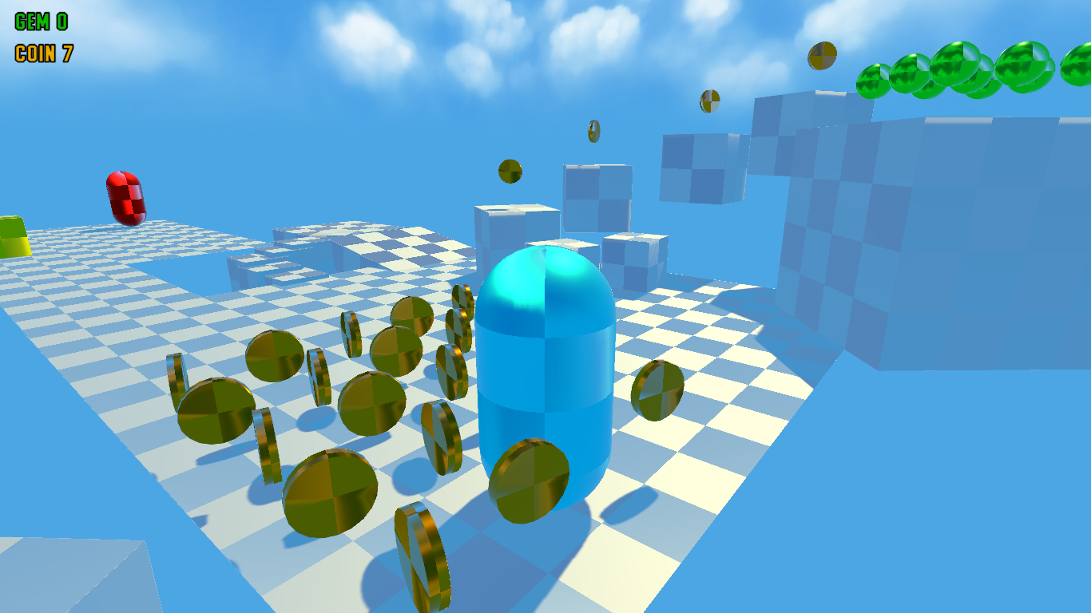
Рис 1 - пример работы игры
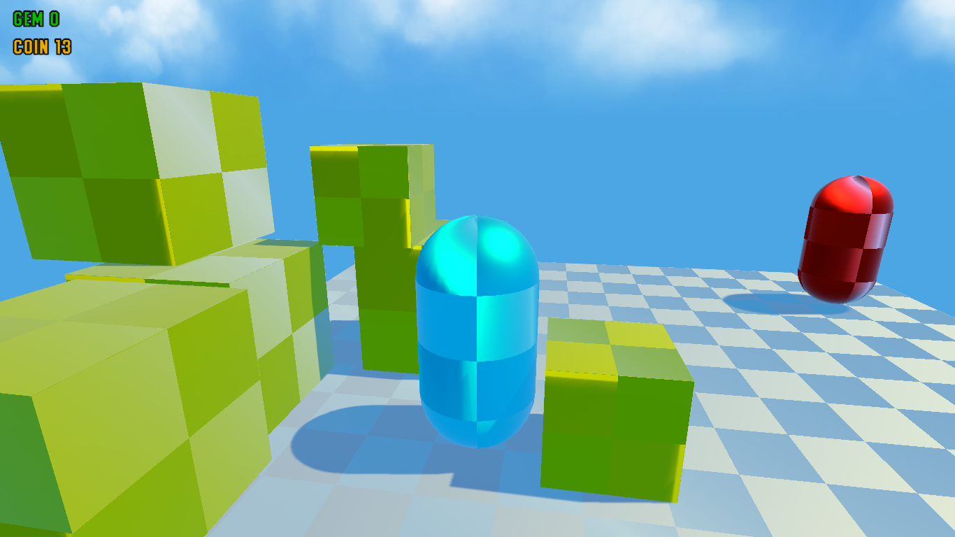
Рис 2 - пример работы игры

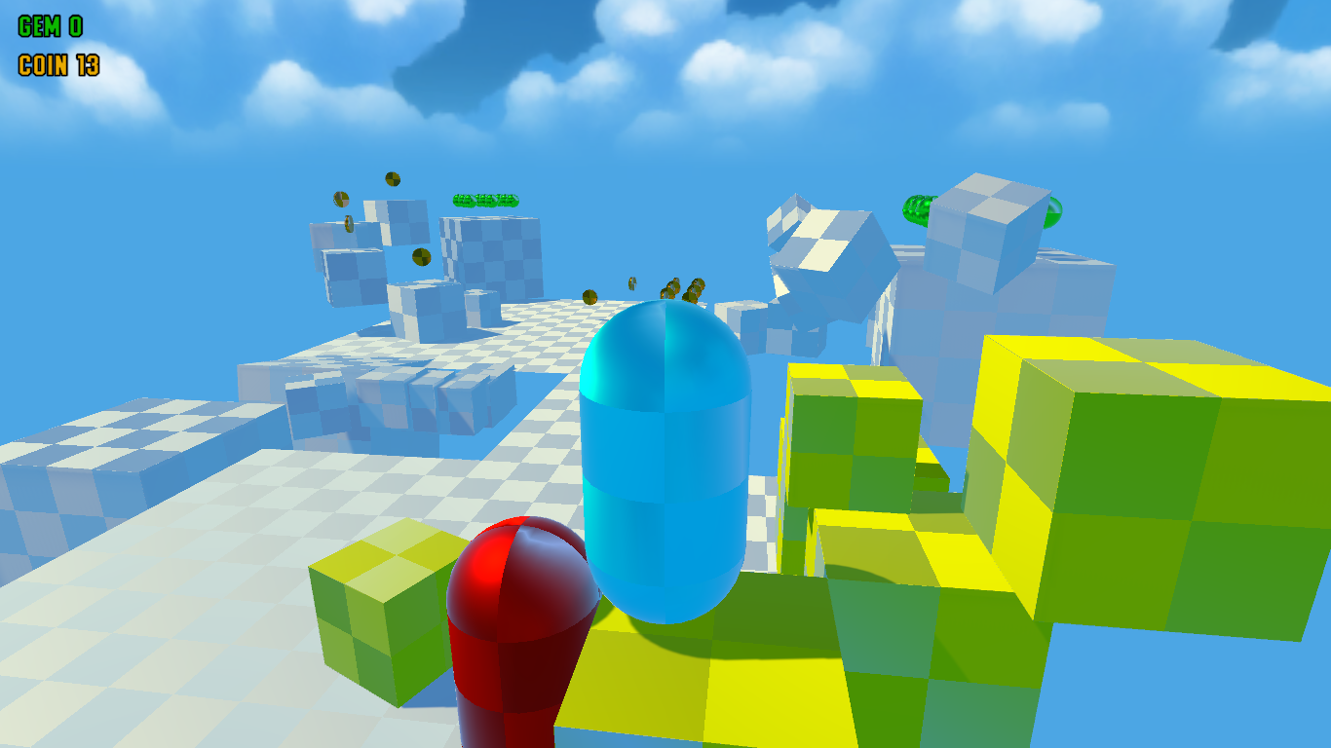
Рис 3 - пример работы игры

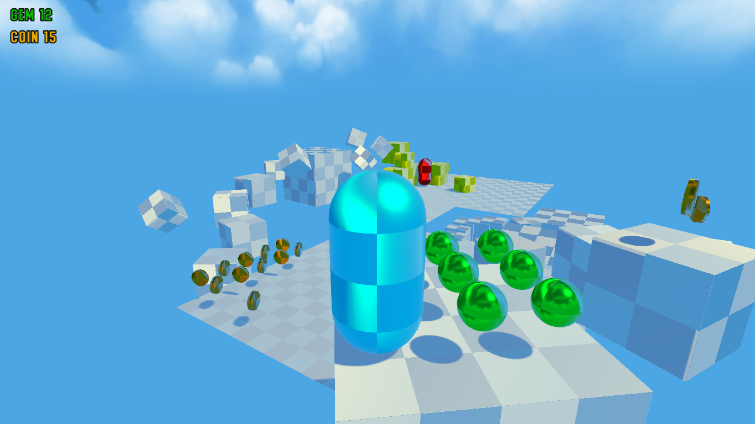
Рис 4 - пример работы игры

